Jenkins Task 1

Task Description:
Launch jenkins and explore creating projects and users.
Launched AWS ec2 for Jenkins with inbound 8080 port access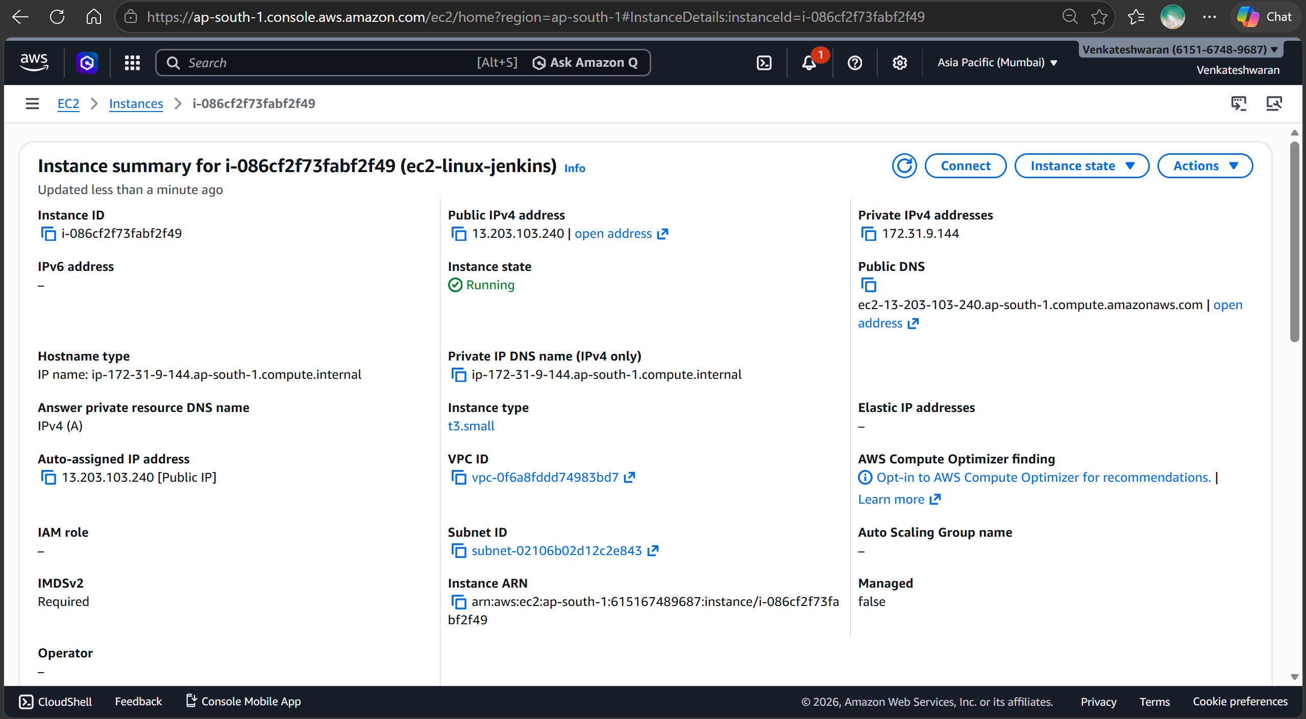
Installed Jenkins in ec2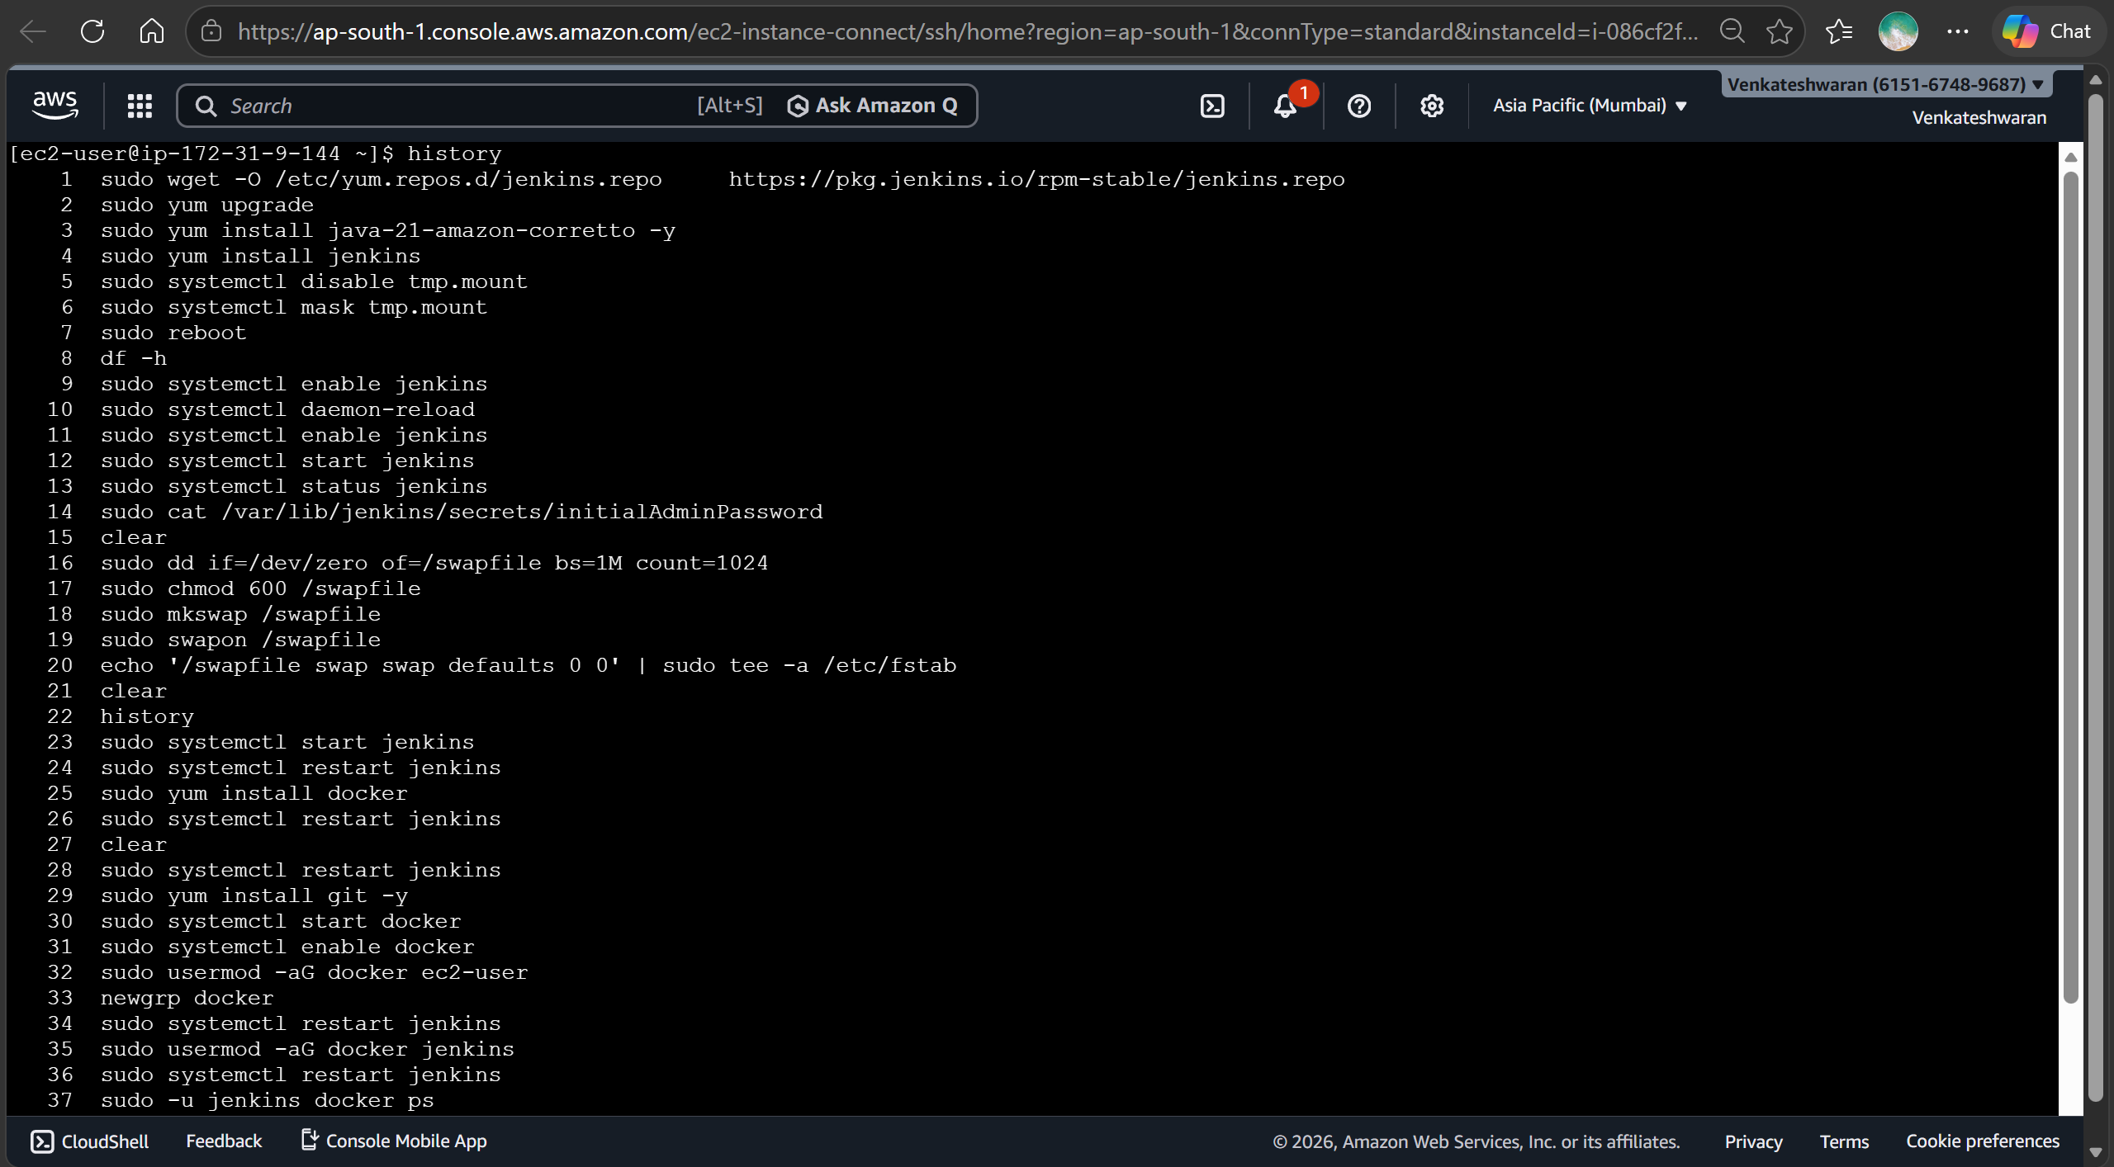
Launched Jenkins and created some jobs(with parameters& parallel) executed successfully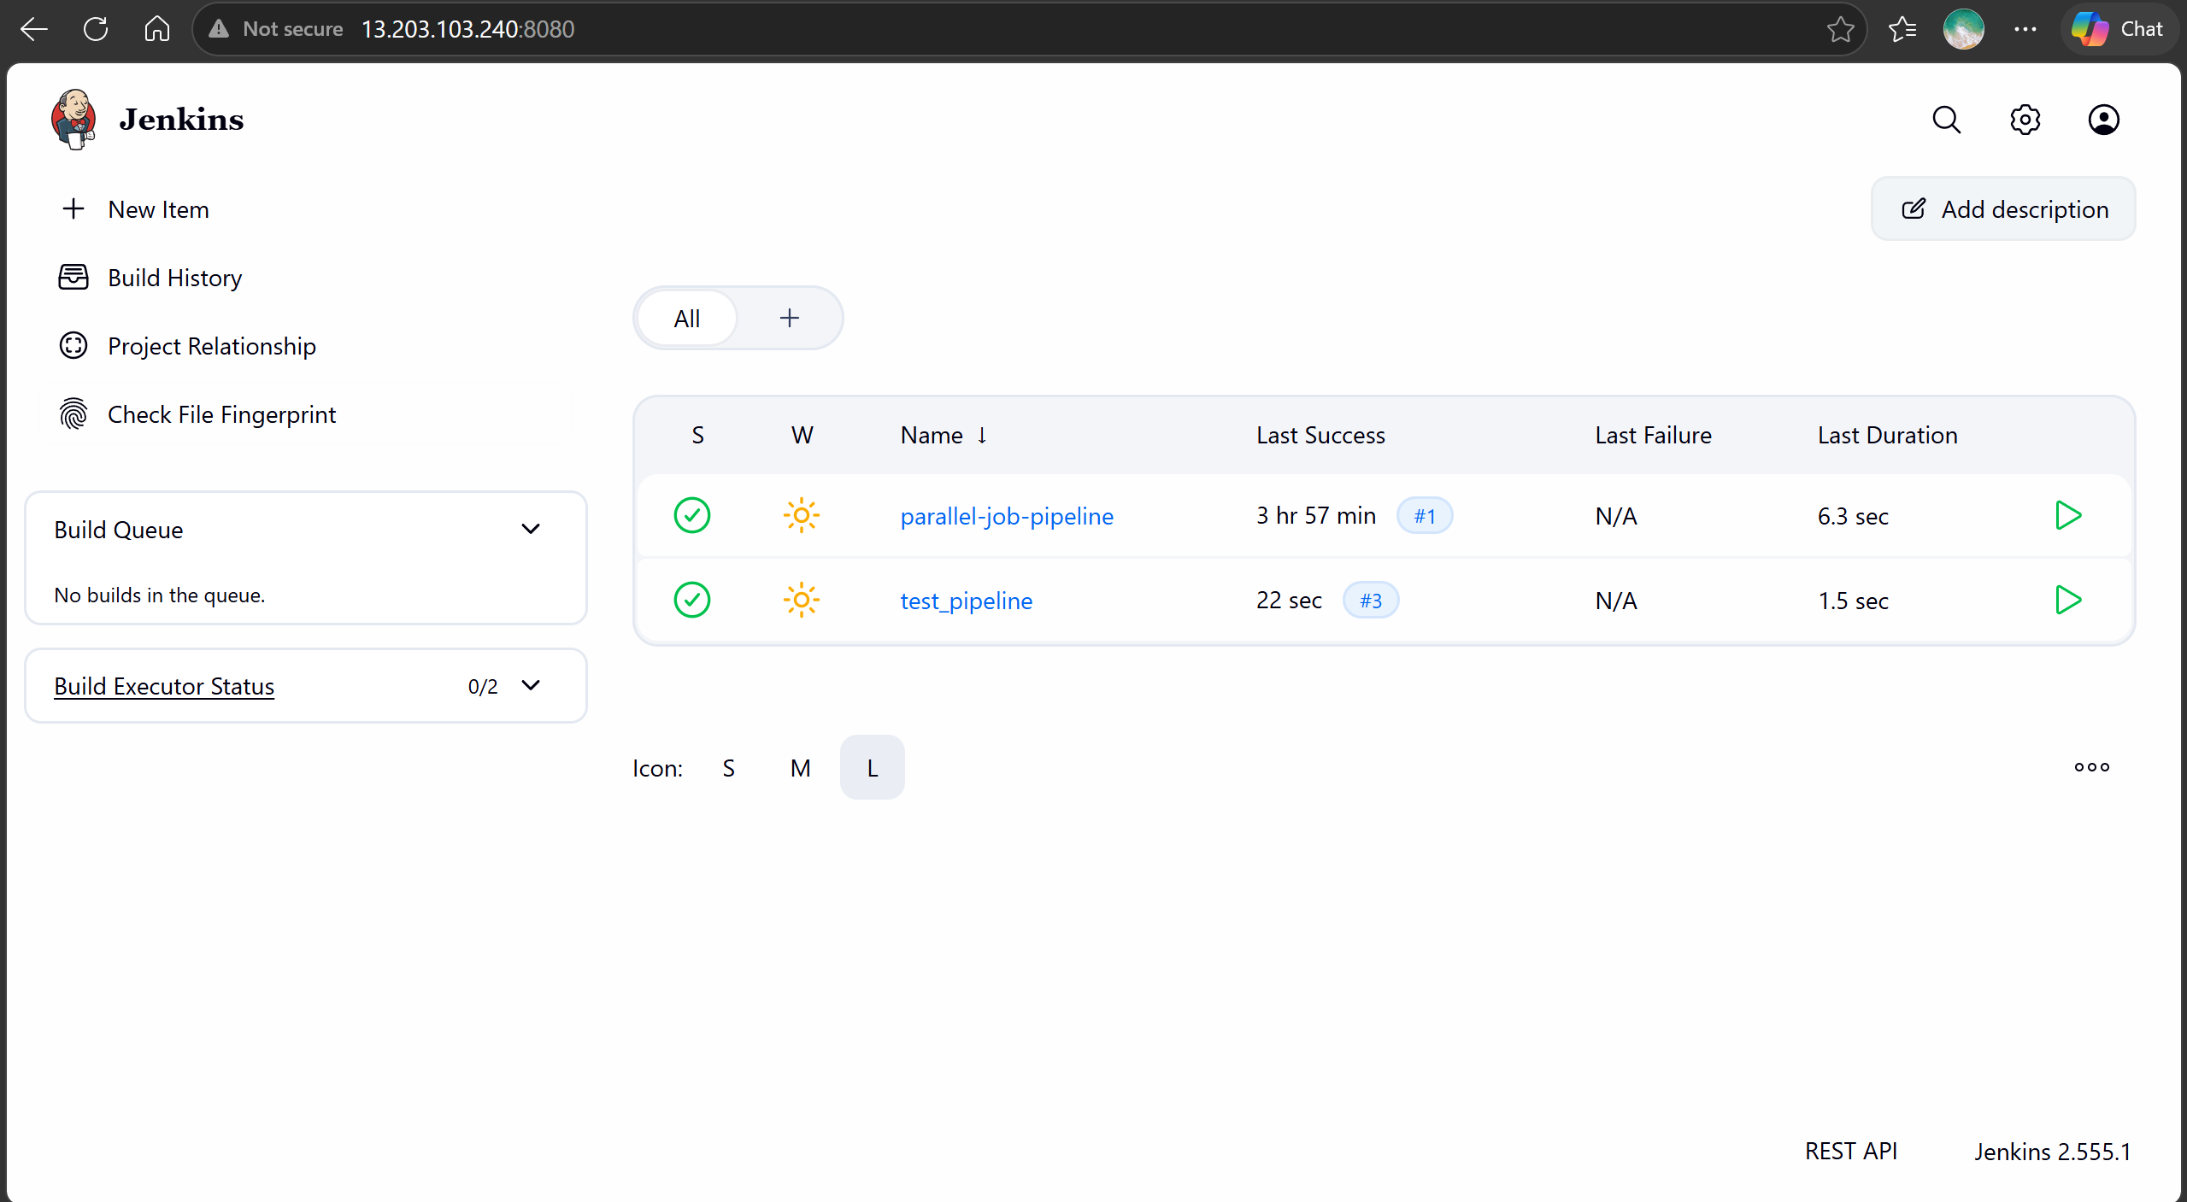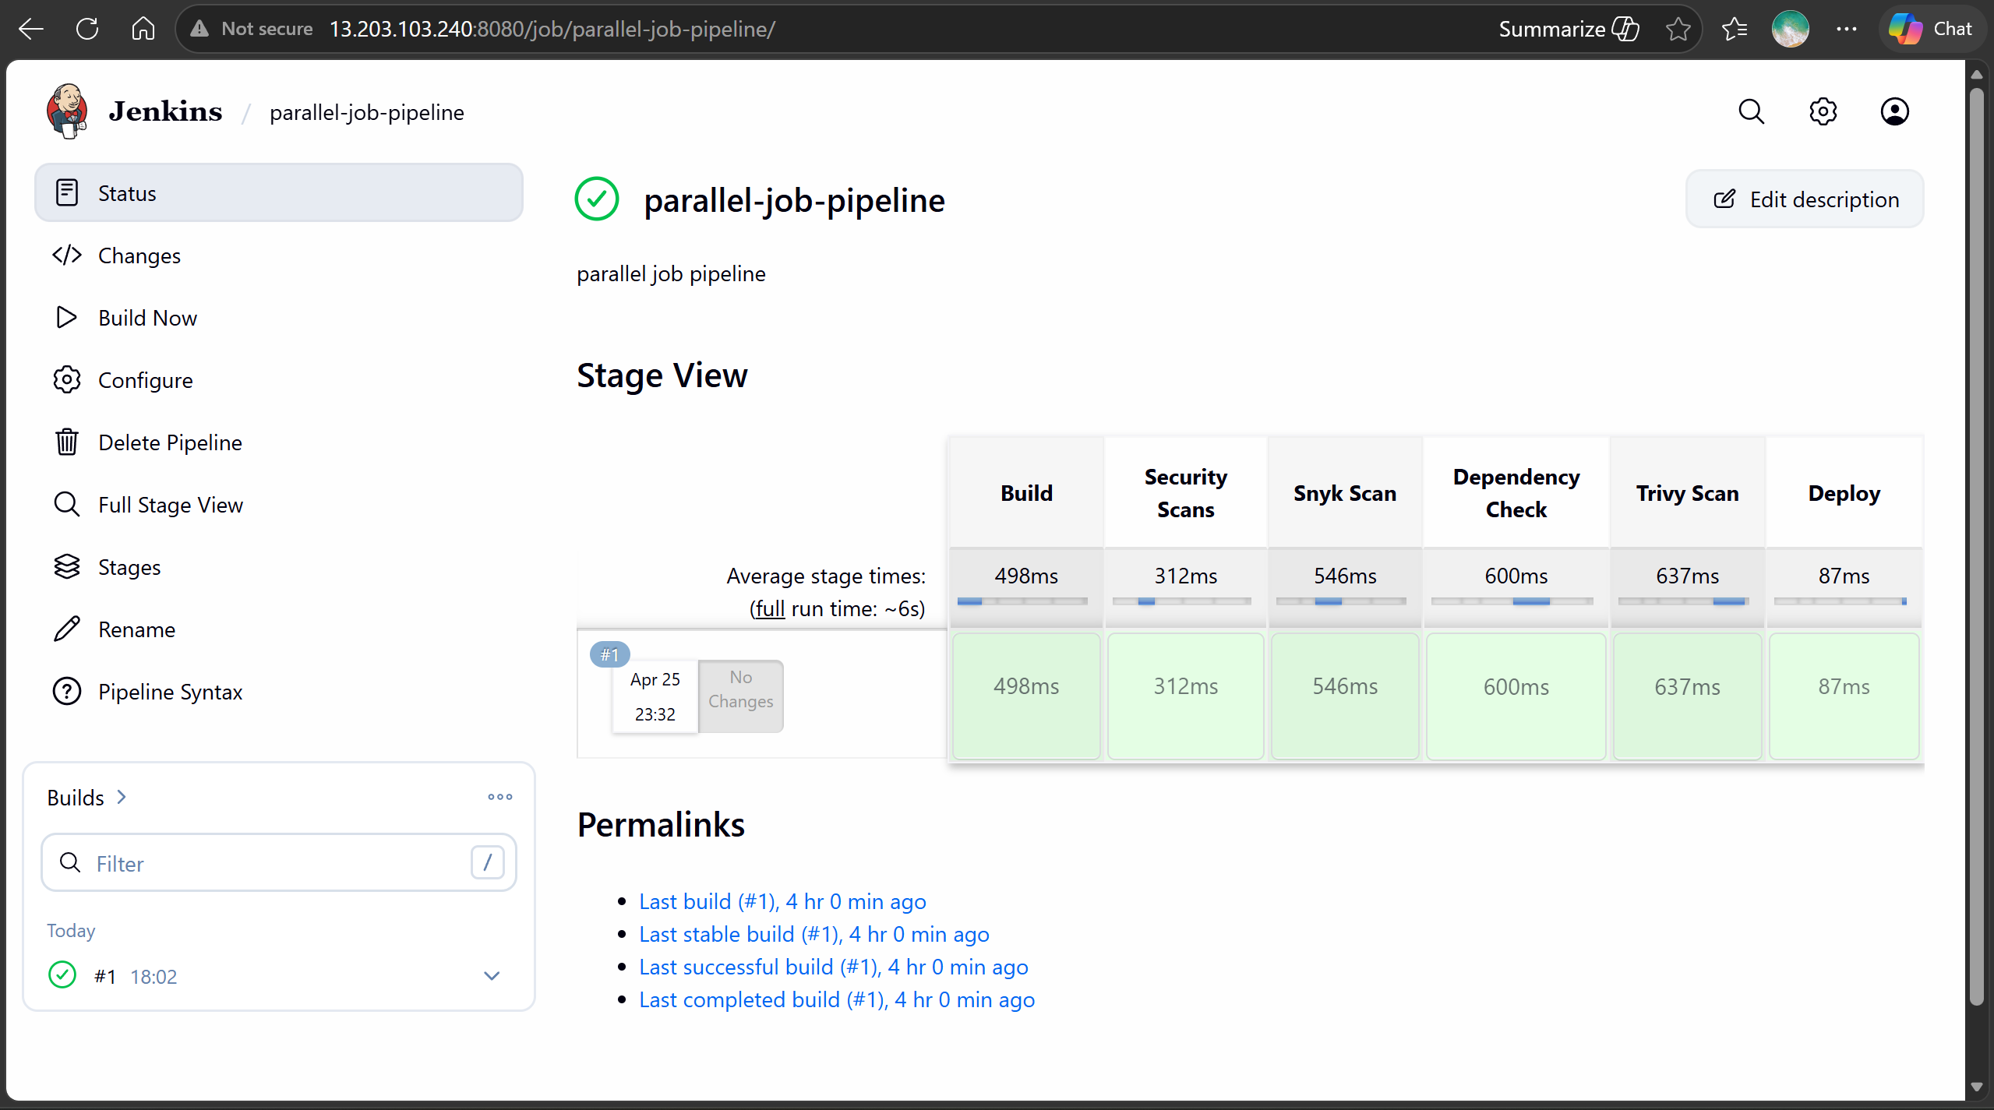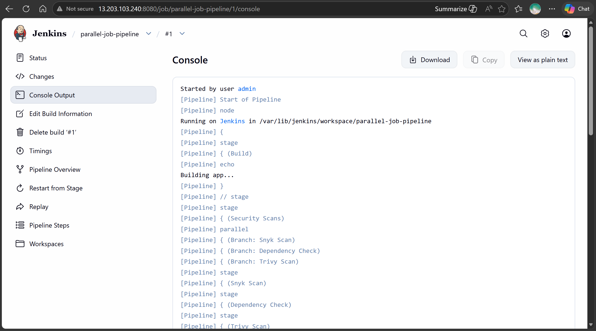
Build with parameters executed 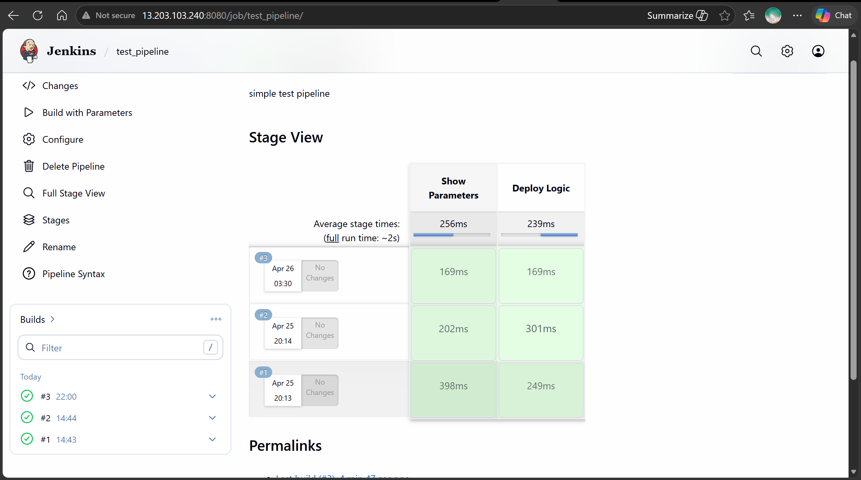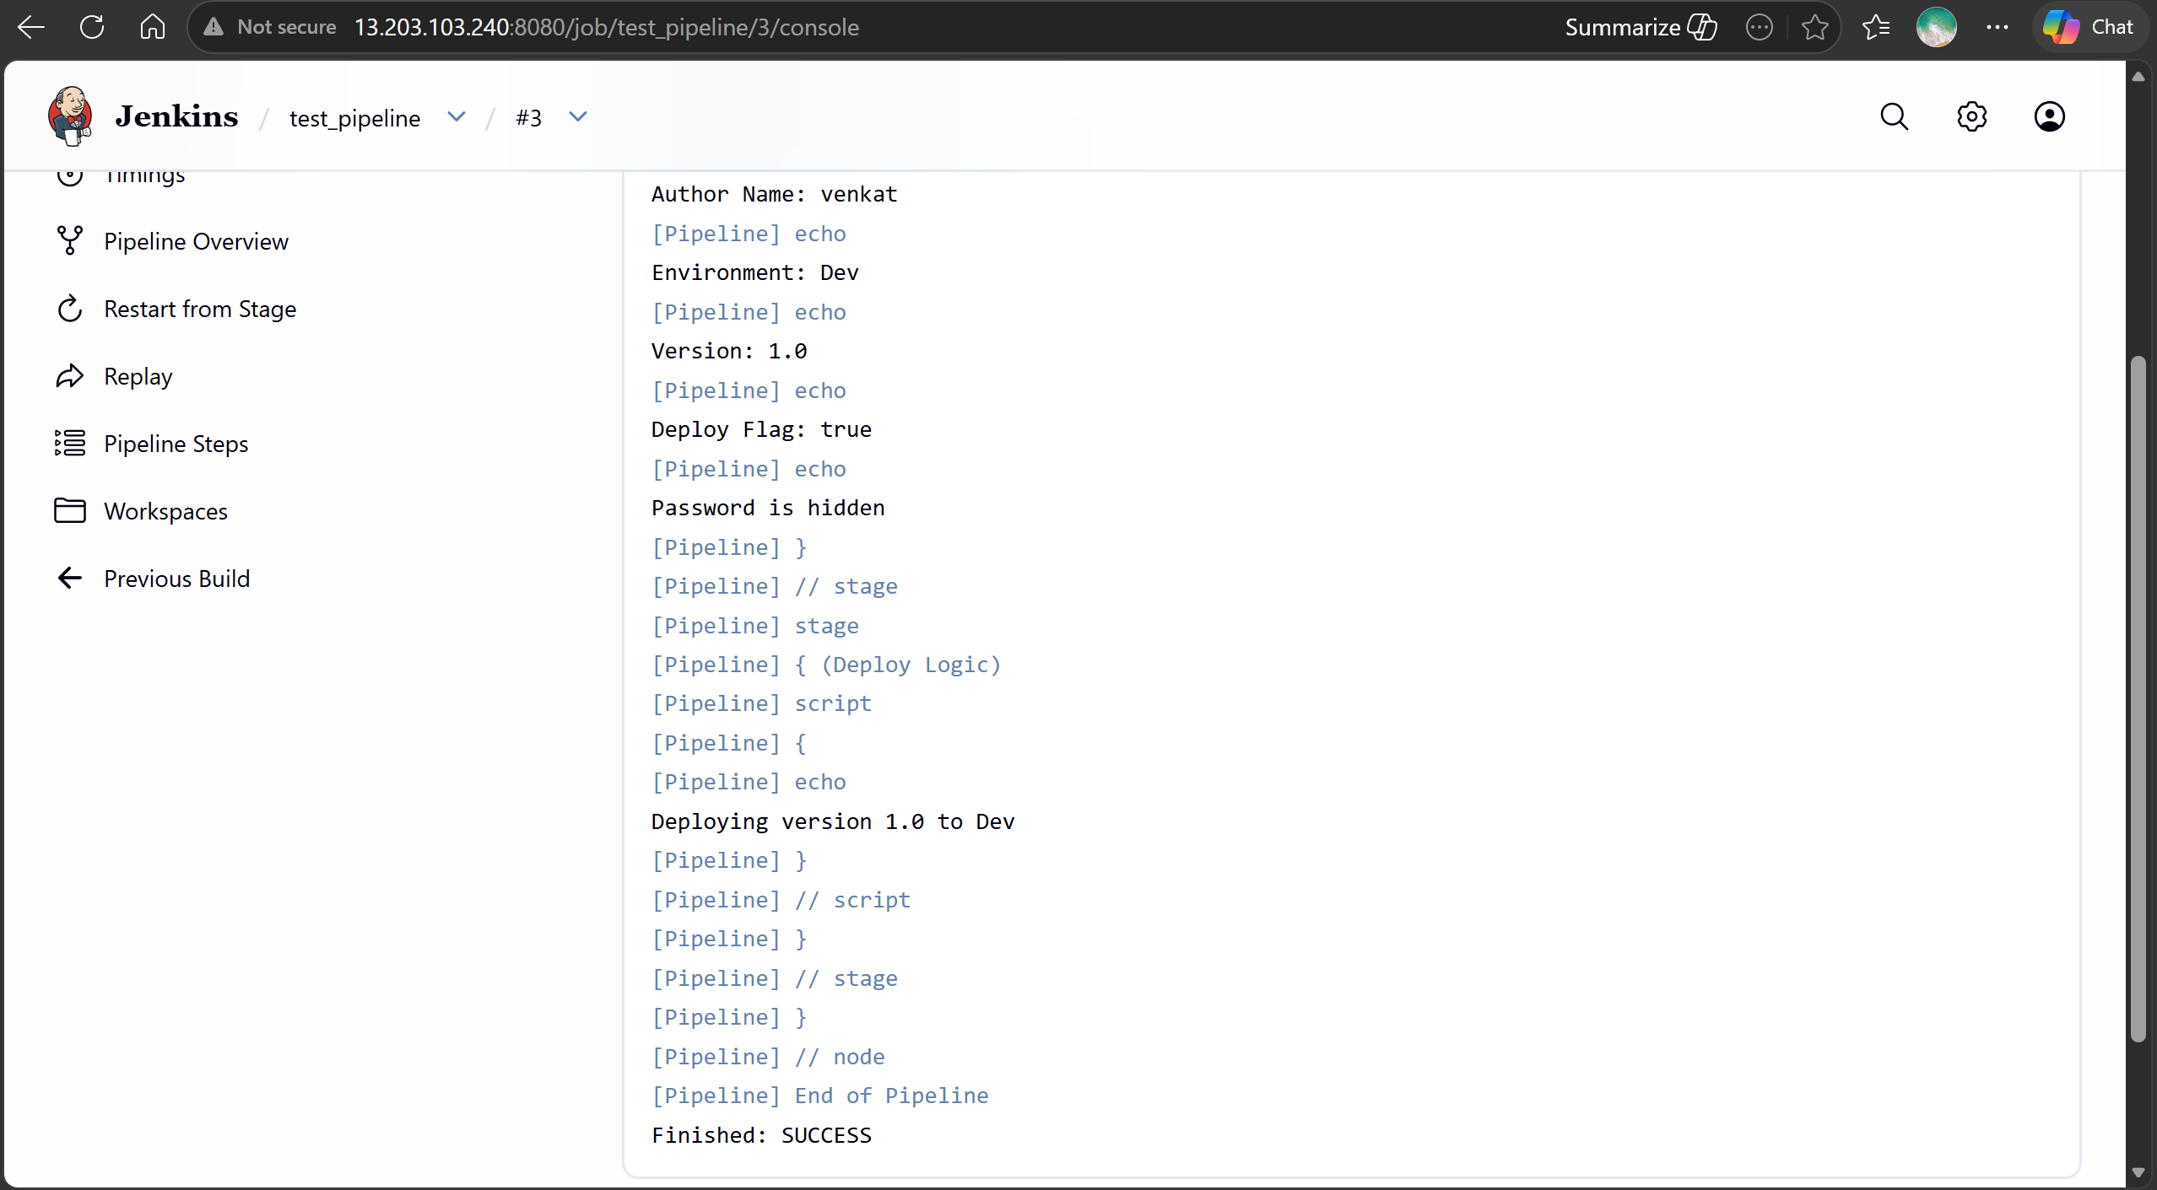
Also created 2 user test_user & prabhu as tester & developer and assigned build, delete, modify acess for tester and only read access for developer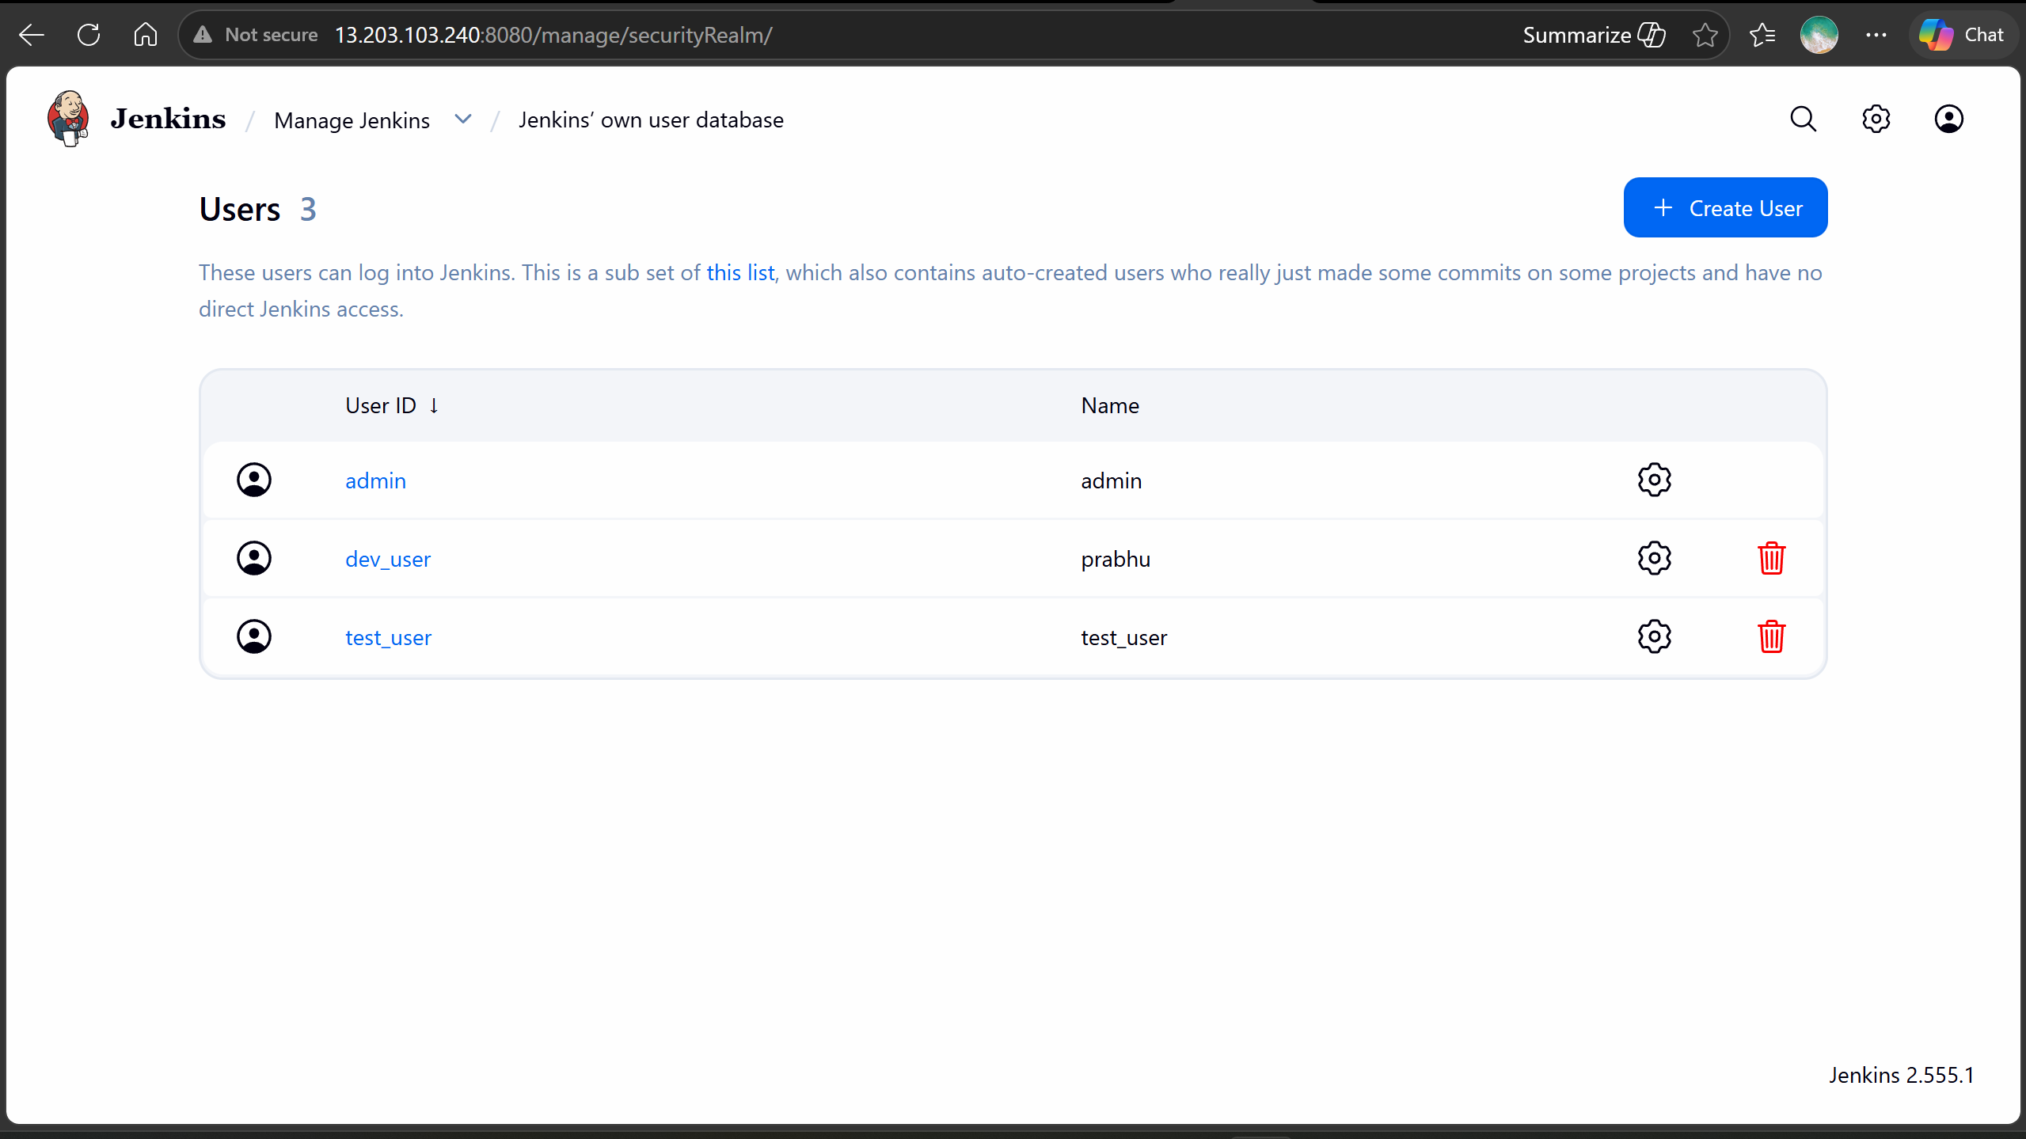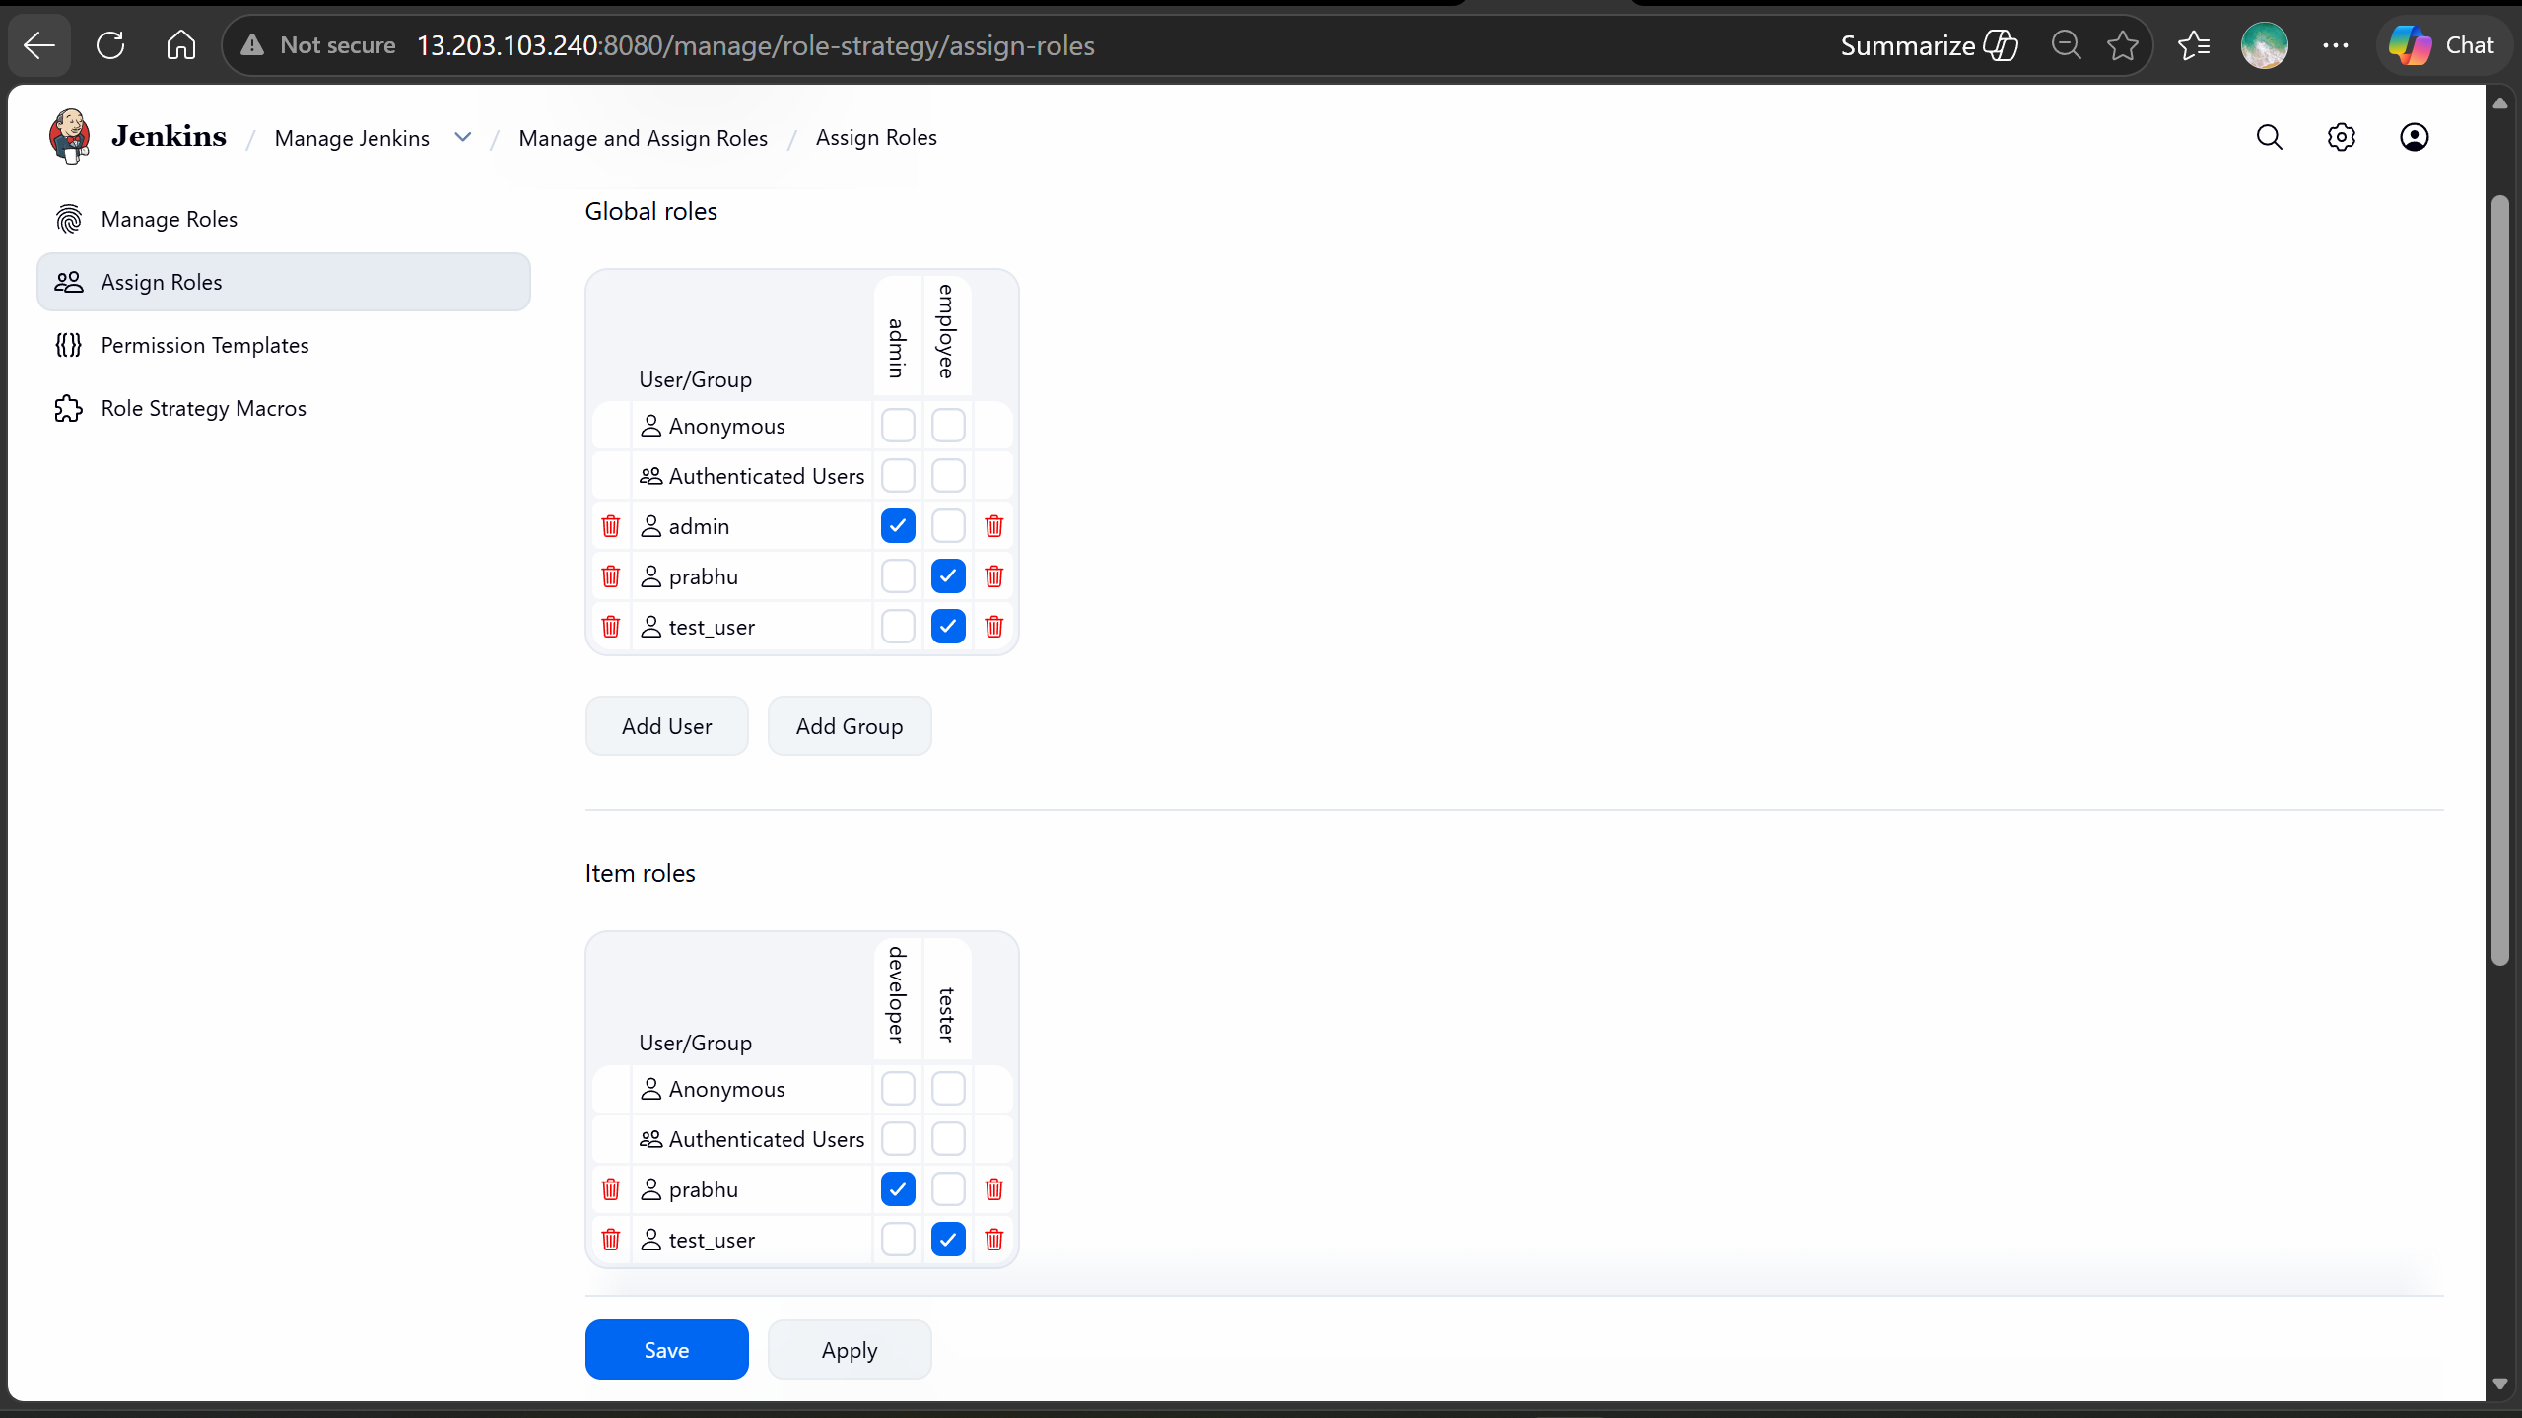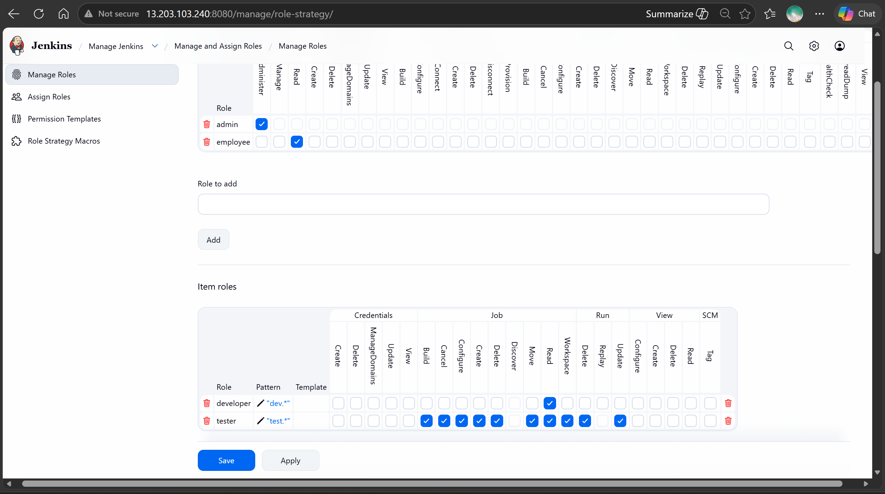

Test_user with most permission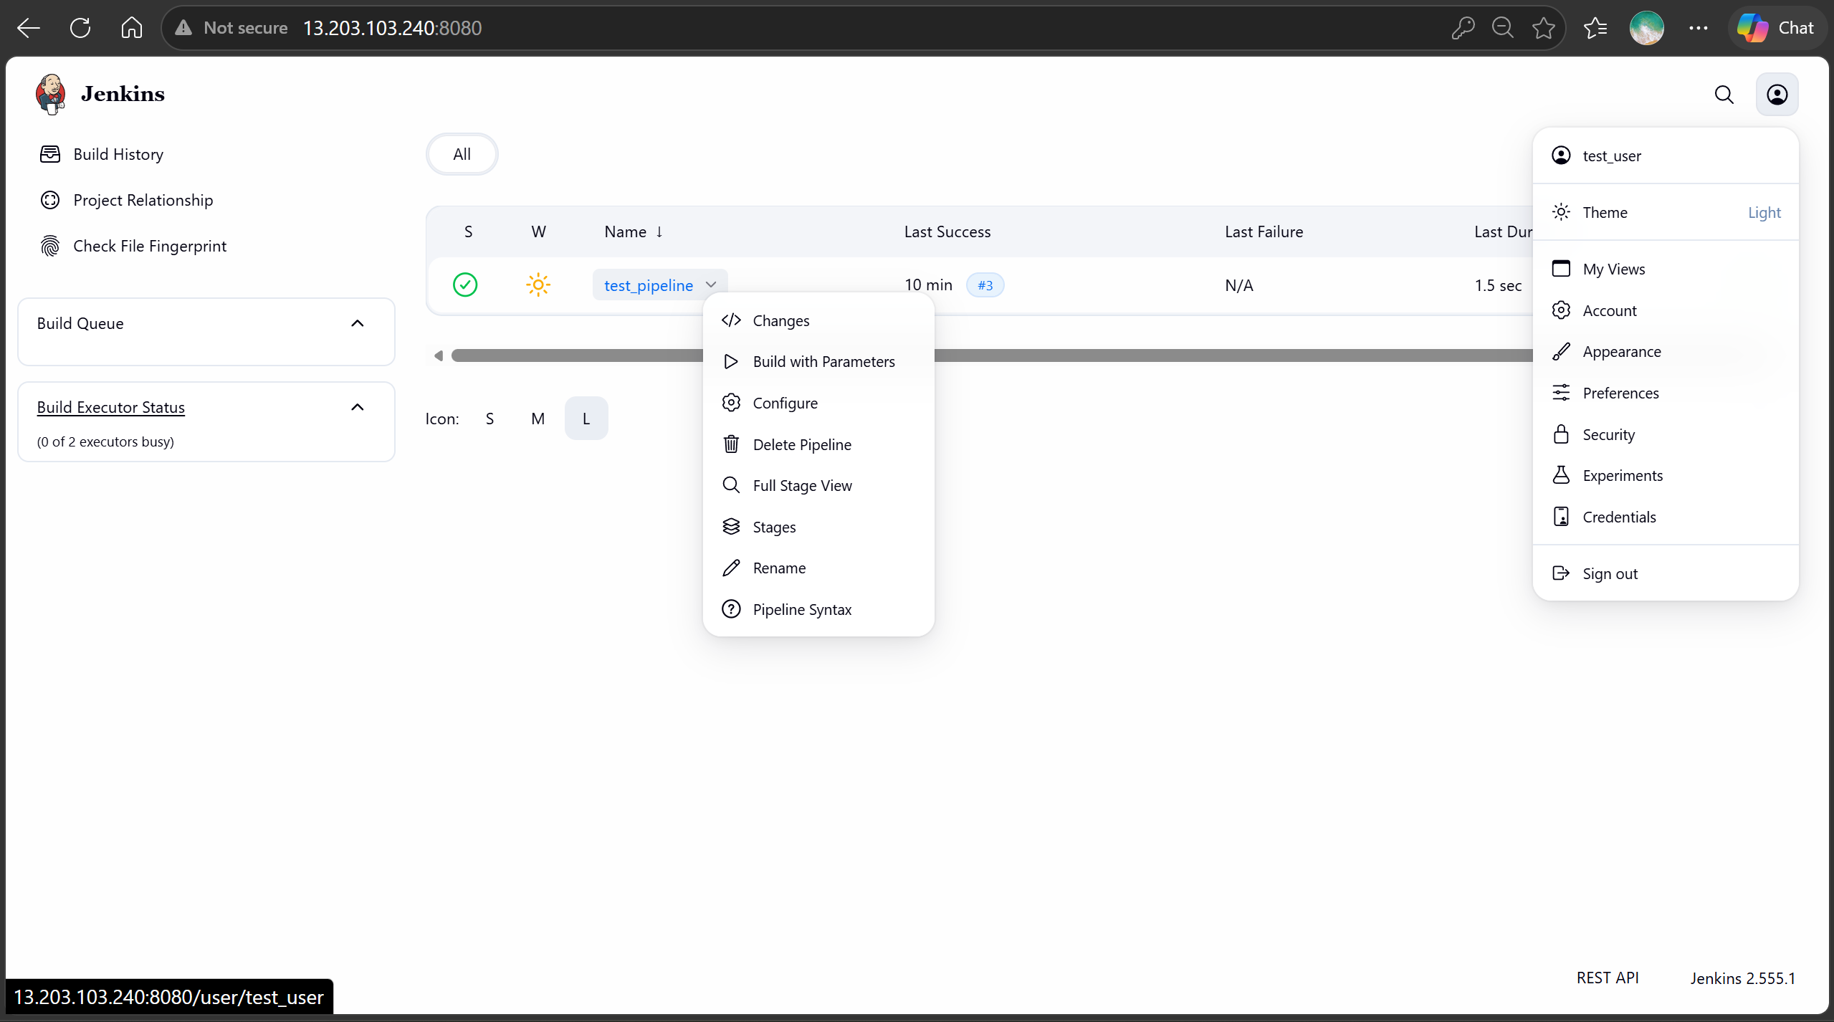
Dev_user with only overall read permission